The requirement to create a file store service, has been achieved using java APIs. The architecture diagram of the client , along with various design assumptions have been described in this document.

The code was developed on a Intellij IDE environment.

Client side design

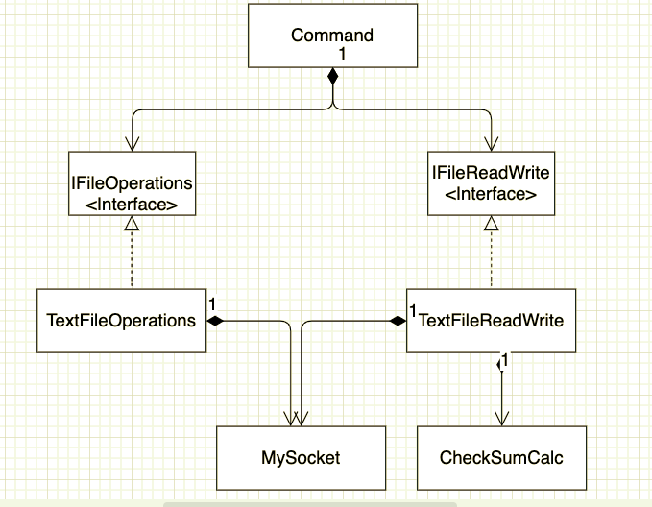

Execution instructions.

The client side can be executed from the command prompt by going to the directory where the FileClient.class is located and running the command

To add/update a file  
  
java FileClient add <input file absolute path>

To remove a file

java FileClient rm <input file absolute path>

To list files in server

java FileClient ls

To get word count

java FileClient wc

To get freq-words

java FileClient freq-words

Assumptions made

* Add and update functionality have been merged into one. If a file already exists on the server, then the file will not be retransmitted
* If an existing file, with a different content is added, then the existing file is updated.
* ls , wc and freq-words will consider all the files in the current directory of the server. This will include files which are not created by the client.
* Have currently only considered text files.
* Using SHA-256 for checksum calculation.
* Assuming the client and server are present on localhost. Hence using HOST as localhost and port as 1988
* Sending files in chunks of 1024 bytes